Software Requirements Specification
for
Project 10 – Distributed informatic system for the management of stocks and sales for a car rental company
Version 1.0

Prepared by
Group Name: Calculatoare Engleza Anul 3
Belu Florin Andrei
Barbu Constantin-Mihai
Marinescu Nanina-Andreea
Pîrvulescu Andreea-Beatrice

Instructor: | Stoica Spahiu Cosmin
Course: | Project II – Use of Databases
Date: | 14.03.2020
Table of Contents
Table of Contents ii
1 Introduction 1
1.1 Document Purpose 1
1.2 Product Scope 1
1.3 Definitions, Acronyms and Abbreviations 1
1.4 References and Acknowledgments 1
2 Overall Description 2
2.1 Product Functionality 2
2.2 End Users and Characteristics 2
2.3 System Stakeholders 2
2.4 Operating Environment 2
3 Specific Requirements 3
3.1 User Interface 3
3.2 Functional Requirements 3
3.3 Use Case Diagram 3
4 Non-functional Requirements 4
4.1 Software Quality Attributes 4
5 Other Requirements 5
Appendix A - Group Log 6

Introduction
The software described in this document is a car rental service website complete with associated support pages, user interfaces, database management that allows the reservations to be made.
This document seeks to provide the Software Requirements Specifications for the car rental website, and contains an introduction, overall description, specific requirements and non-functional requirements with respect to the current stage of the project.

Document Purpose
The purpose of this document is to record the requirements for the design and
development of a car rental service website. It describes requirements for a future, complete version of the project, to be created in the spring of 2020. There may be a need for future updates to the document.
Moreover, this document reflects the current requirements of the project as understood by the project team, presenting an initial description of the various functionalities and services provided by the software. Additionally, it may also serve as a basis for testing by the user.

Product Scope
The scope of the website is not only limited to attracting and encouraging people in need of transportation and car enthusiasts to consider using the rental services, but also aims to
provide relevant information and various options, keeping in mind that the person visiting this website wants a full knowledge of the availability and facilities of the vehicle to be rented.
The scope of the website is to provide a user-friendly set of web pages that are easy
to navigate and at the same time provides sufficient depth and information about car rentals.
Two potential groups of viewers exist:
1. People in need of transportation, especially tourists that need to visit multiple places in a short amount of time.
2. Car enthusiasts, people that want to test the capabilities of a certain type of vehicle before deciding whether to purchase it or not.
The goal of website is to encourage more people to choose rental services, eventually increasing the profit of the company, improvement of the services, and most importantly helping people with their business. Maintaining a simple and friendly site is deemed of highest importance in order to hold customer attention and guide the viewer to information that will lead to a decision to rent the best vehicle available.

Definitions, Acronyms and Abbreviations

>>To be added as the project is implemented.

References and Acknowledgments
https://www.w3schools.com/
www.sixt.com
https://www.booking.com/cars.html

Overall Description

Product Functionality
- The company has in stock a number of cars with a license plate number, no. of km travelled, date of manufacture, a brand, type and price per hour.

- Each brand has names and details. Each type has names and details.

- Each car is in a class (compact, limousine, etc.).

- Each class has name and description.

- There is a list of customers who have first names, email, phone, address.

- A rental history is preserved (what customer rented what car, since when to until when.).

- Each car will retain its current status (rented, unrented)

- A record of unwanted customers who have had incidents during the rental is kept.

End Users and Characteristics
This website will be used by three types of users.
- Admin – the administrator will be able to access a database of customers, update certain parts of it and also add car listings for the customers to rent.
- Customer – The users which have logged in are considered customers. They will be able to rent a vehicle, view their rented vehicles, receive recommendations and use various interactive options on the website such as signing up for a newsletter and sending messages to the admin.
- Guest – Users which have not logged in, have limited accessibility to the website. They will need to log in to rent vehicles and use the rest of the services, however they will still be able to browse the website fully.

There are mainly four types of customers:
1. People in need of transportation, who will regularly use the car rental services.
2. Tourists who will require a rental to get around the city easier.
3. Car enthusiasts who simply enjoy driving different cars as a hobby.
4. People that want to buy a car and prefer to ride a rental before making a decision.
If it is necessary, the website should undergo design changes to all existing pages to shorten up
paragraphs and add bullets and charts where possible to accommodate faster page reading and shorter reader attention span keeping in mind most of the users do not have great technical expertise and are looking for a simple and well-structured car presentation in order to rent it easier.

System Stakeholders
The system stakeholders could be:

Acquirers | Oversee the procurement of the system or product
Assessors | Oversee the system’s conformance to standards and legal regulation
Communicators | Explain the system to other stakeholders via its documentation and training materials
Developers | Construct and deploy the system from specifications (or lead the teams that do this)
Maintainers | Manage the evolution of the system once it is operational
Production Engineers | Design, deploy, and manage the hardware and software environments in which the system will be built, tested, and run
Support Staff | Provide support to users for the product or system when it is running
System Administrators | Run the system once it has been deployed
Testers | Test the system to ensure that it is suitable for use
Users | Define the system’s functionality and ultimately make use of it

Operating Environment

This software being developed will be compatible with machines running on Windows.
Mozilla Firefox will be the main browser used to test the web site, however it will be tested on Google Chrome, Microsoft Edge, etc.
All databases and functional components will be stored on a personal computer for testing purposes.
The hardware that will be used in developing this program consists in an Intel i5-6300HQ CPU, 8 GB RAM, Nvidia GeForce GTX 950M 4 GB. The website will work on almost any machine, so the minimum requirements are trivial. The synchronization procedures will be written to interface with Windows operating systems. There are no software components that are in conflict with this project, the website can be tested as is.

Specific Requirements

User Interface
The website will feature a home page which contains a summary of all the features, a simple, interactive presentation of some featured cars, statistics, stocks and sales information.
It will also feature an “about us” page containing information about the site owners and a car listing page which will contain the database of all available cars, complete with detailed information about all of their features and prices, including current availability.
There will also be a FAQ page with frequently asked questions about the car rental services and a “contact us” page containing contact information. There may also be buttons which contain links to social media.
The user has the ability to log in and rent a car. There is a search bar which can easily find a specific car, or it can be selected from the car listing page. Users also have access to their personal profile where they can see the bookings they have made, and can be suggested cars similar to the ones they’ve booked.
Satisfied customers, a newsletter, and a special admin login button are also available.
The website should work and be tested against Microsoft Edge, Firefox, Google Chrome.\
A wireframe model of an early version has been attached.

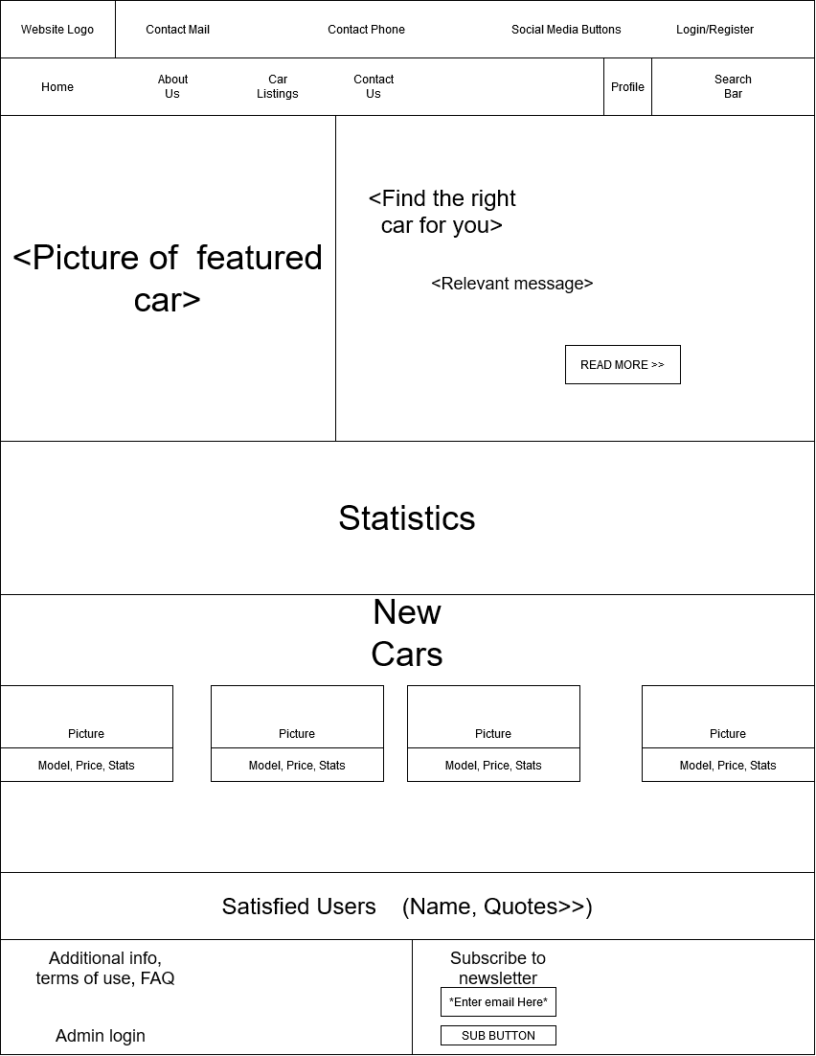

3.2 Functional Requirements

Some functional requirements for a car rental website:
1. Usability:
- The web application shall accept customer bookings unless they are not available.
- The web application shall be able to cash in a rent fee.
- The web application shall produce a receipt detailing a customers’ purchase information and include name of customer, items purchased, cost of each item and total cost
- The web application shall be able to produce weekly, monthly and yearly reports about sales.
2. Quality:
- The web application shall contain simple, clean and easy to use interfaces
- The web application shall contain well-placed styles and layouts that fit the chosen theme.
- The web application shall provide the user with all available options at all times to satisfy quality assurance.
3. Performance:
- The web application shall contain smooth animations in drop-down menus, sliders and other related features.
- The web application shall contain fast execution times for all features.
- The web application shall manage user login support in a quick and correct manner.

3.3 Use Case Diagram
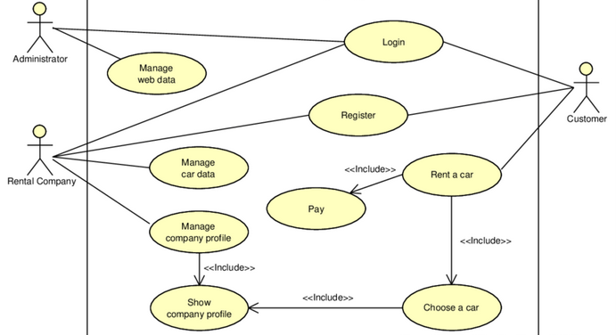

Non-functional Requirements

Software Quality Attributes
Some non-functional requirements for a car rental website:
- The web application shall be easy to use by all employees including sales representatives and managers.
- The web application shall be available in several languages.
- The web application shall allow several sales to be made at the same time without downgrading performance.
- The web application representatives shall provide quick customer support for all users that have submitted a ticket.
- The web application FAQ and future updates shall be done based on the user feedback.

Other Requirements
None.

Appendix A - Group Log
The work has been divided equally among the 4 team members. Every team member has been given permission to handle a quarter of the document. This resulting document is the work of 4 people.

